***Oracle SQL Assignment Questions***

### 1. **Basic SELECT Query**

- Write an SQL query to retrieve all columns from the `employees` table.

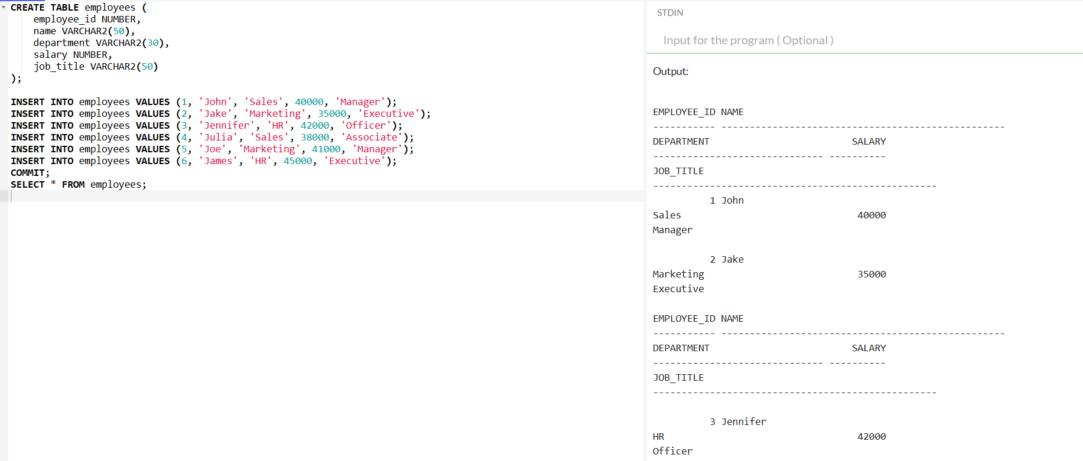

### 2. **Filtering Data**

- Write an SQL query to find all employees who are working in the "Sales" department.

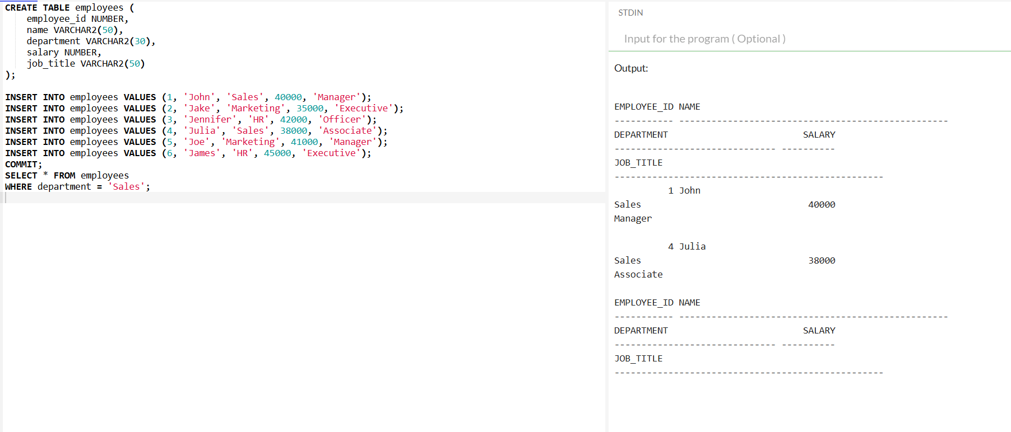

### 3. **Sorting Data**

- Write an SQL query to get the names and salaries of employees in the "Marketing" department, sorted by their salaries in descending order.

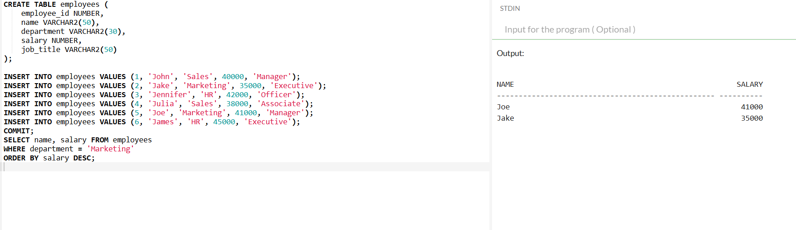

### 4. **Using Aggregate Functions**

- Write an SQL query to calculate the average salary of employees in the "HR" department.

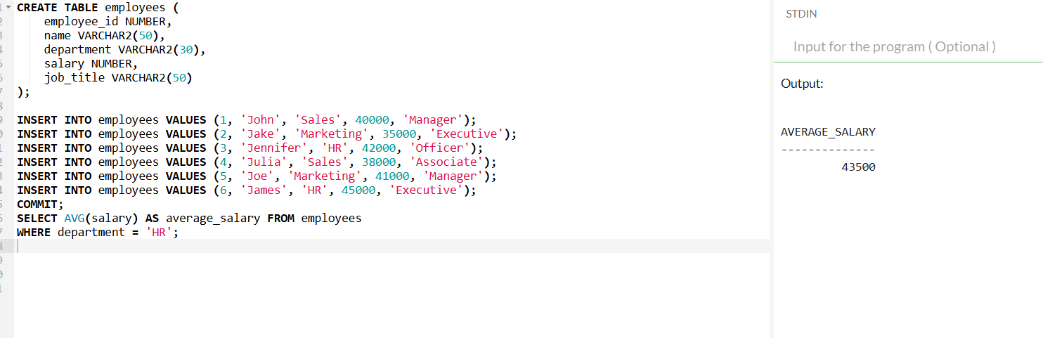

### 5. **Group By Clause**

- Write an SQL query to find the total number of employees in each department.

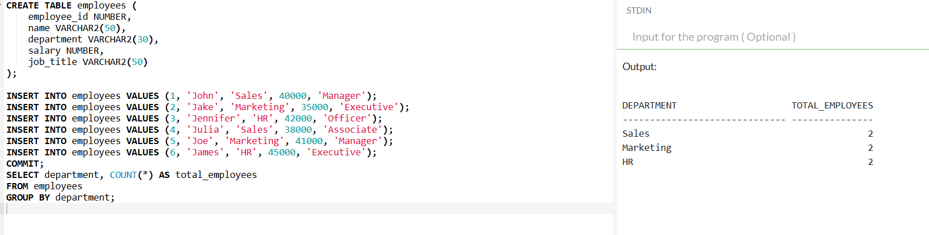

### 6. **Using DISTINCT**

- Write an SQL query to list all unique job titles from the `employees` table.

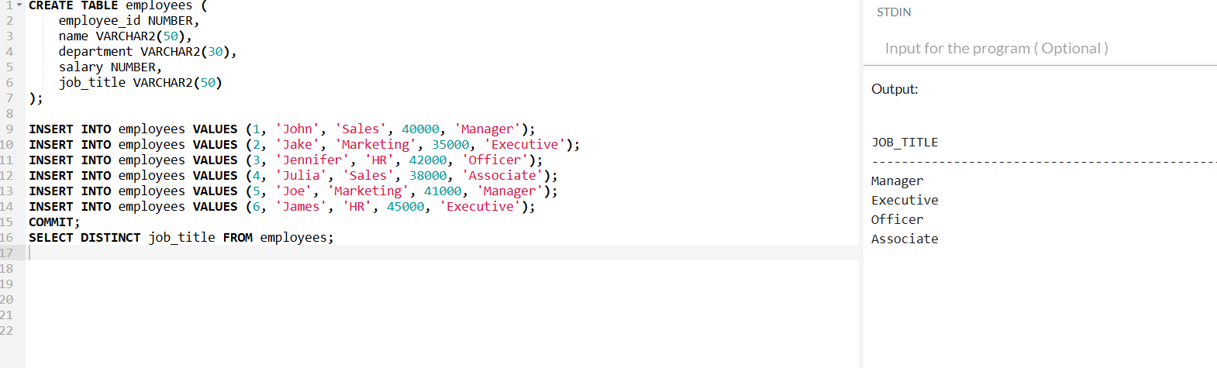

### 7. **Using LIKE Operator**

- Write an SQL query to retrieve all employees whose names start with the letter "J".

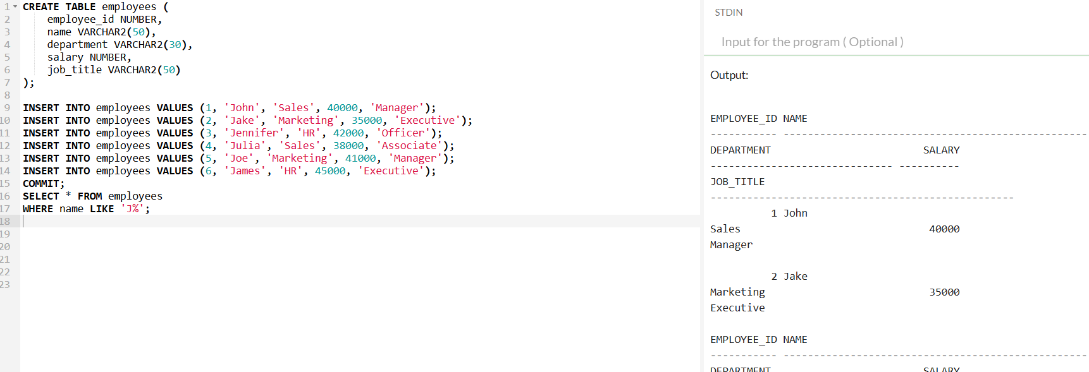

### 8. **Using AND/OR Conditions**

- Write an SQL query to find employees who are either in the "IT" department or have a salary greater than $50,000.

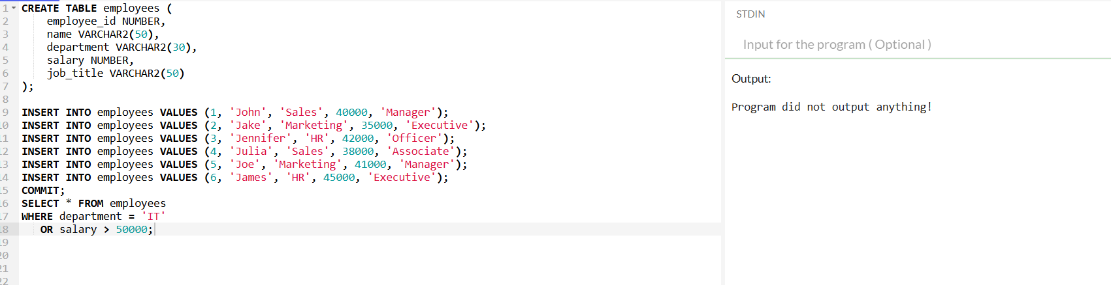

### 9. **Joining Tables (Inner Join)**

- Write an SQL query to display employee names along with their department names by joining the `employees` and `departments` tables.

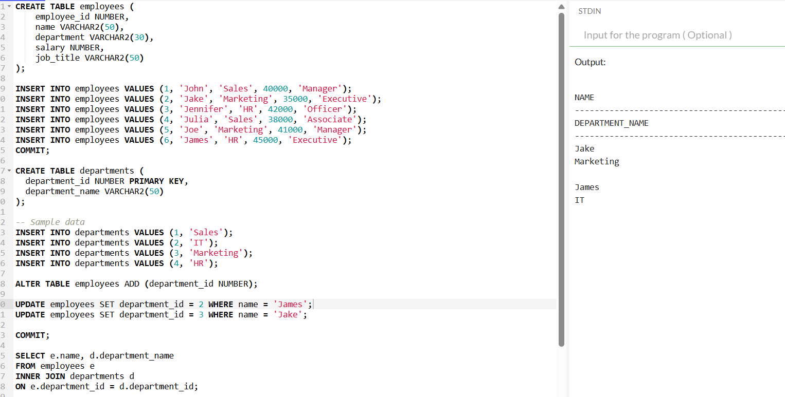

### 10. **Joining Tables (Left Join)**

- Write an SQL query to display all employees and their department names, including those employees who are not assigned to any department.

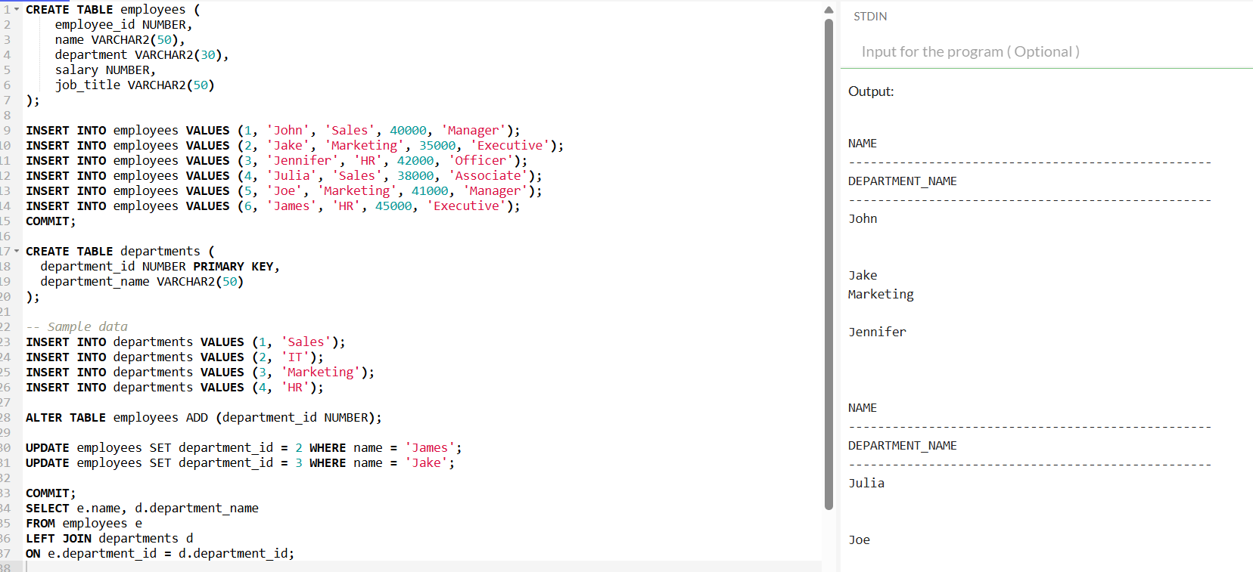

### 11. **Subqueries**

- Write an SQL query to find employees whose salary is greater than the average salary in the `employees` table.

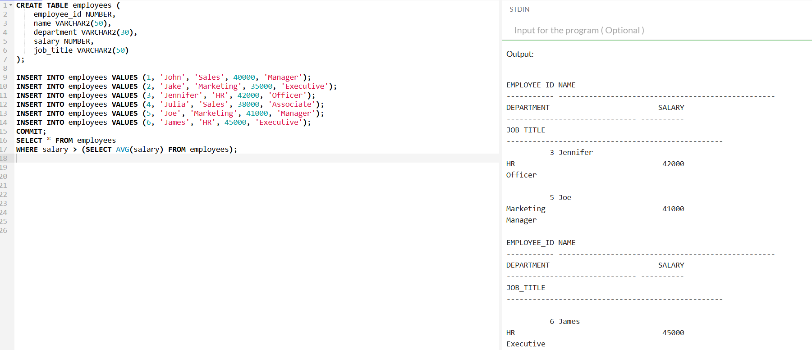

### 12. **Using IN Operator**

- Write an SQL query to list all employees who belong to the departments "Sales", "Marketing", or "HR".

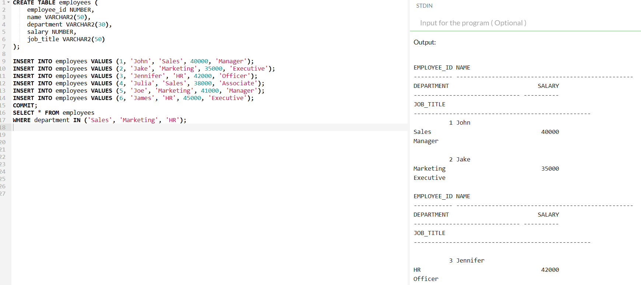

### 13. **Using BETWEEN Operator**

- Write an SQL query to find employees whose salaries are between $40,000 and $60,000.

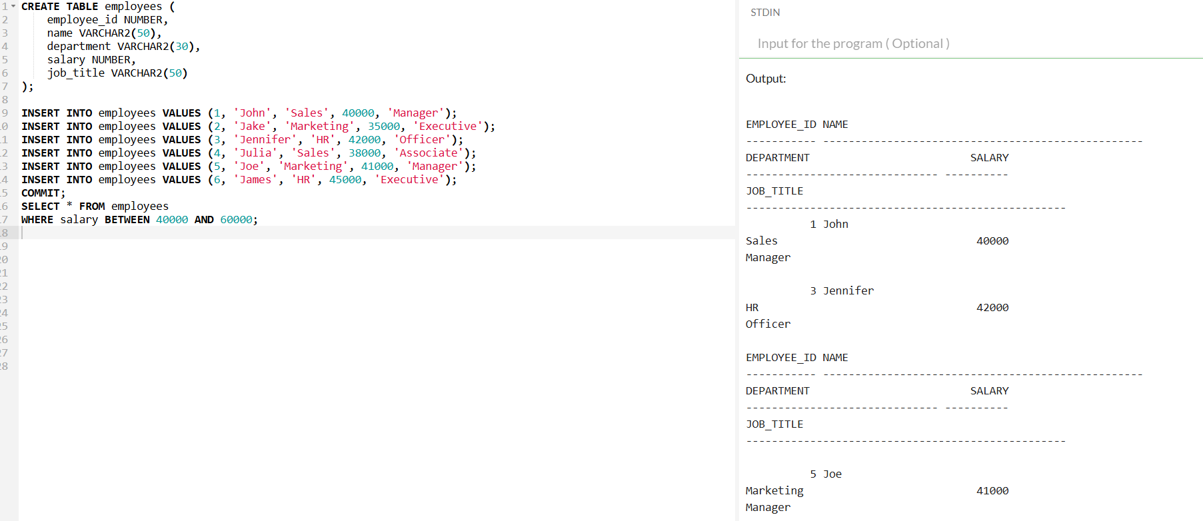

### 14. **Using EXISTS**

- Write an SQL query to find departments that have at least one employee with a salary greater than $70,000.

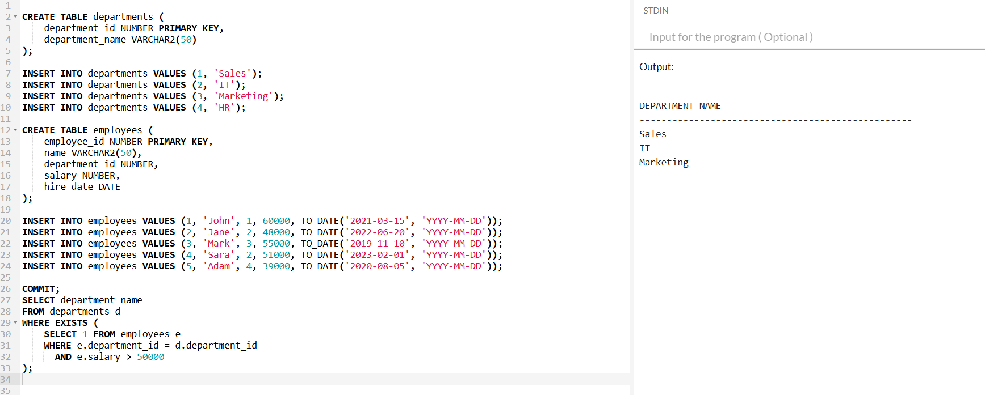

### 15. **Date Functions**

- Write an SQL query to find all employees who joined after January 1, 2020.

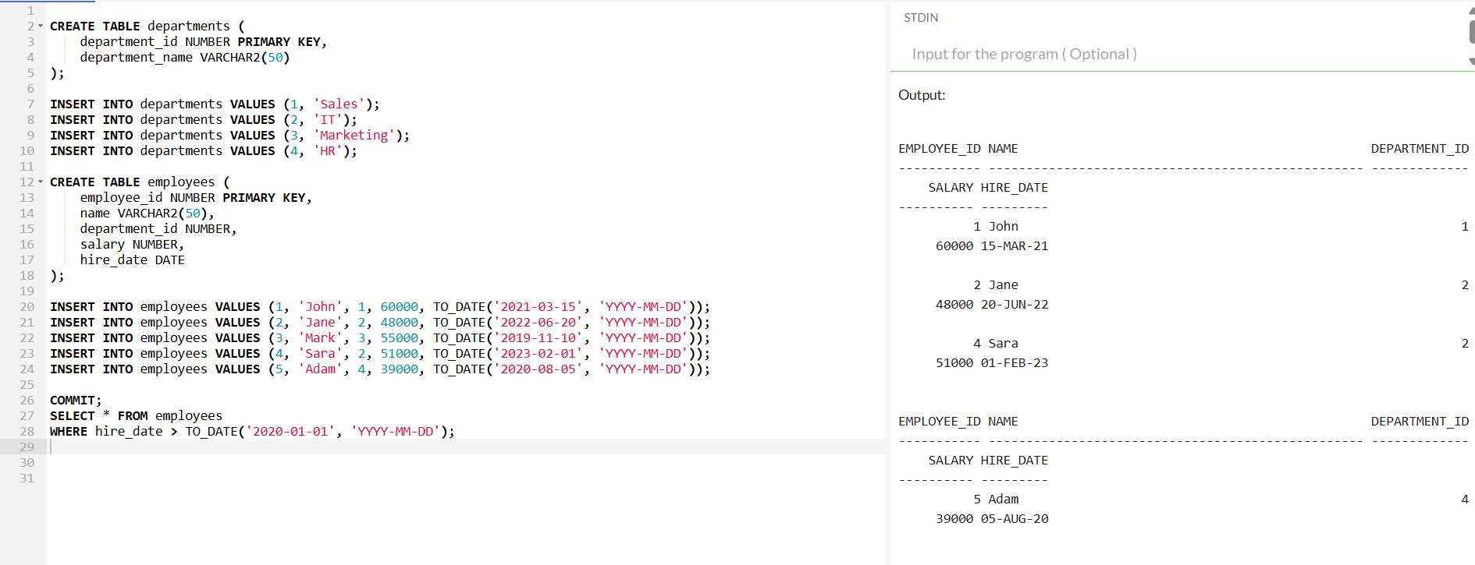

### 16. **Updating Data**

- Write an SQL query to increase the salary of all employees in the "IT" department by 10%.

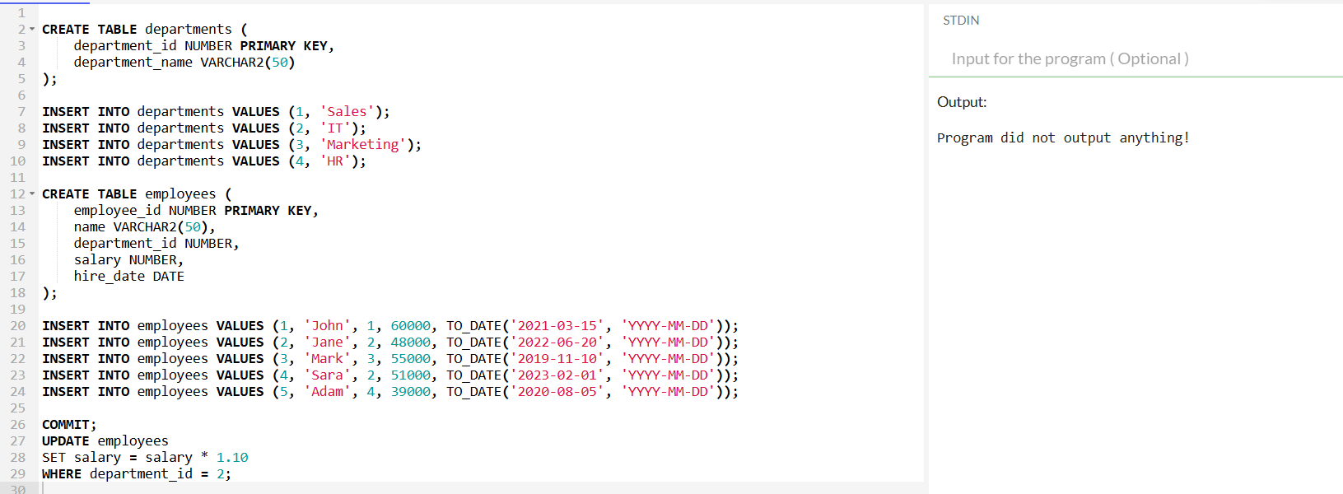

### 17. **Deleting Data**

- Write an SQL query to delete all employees who are no longer with the company.

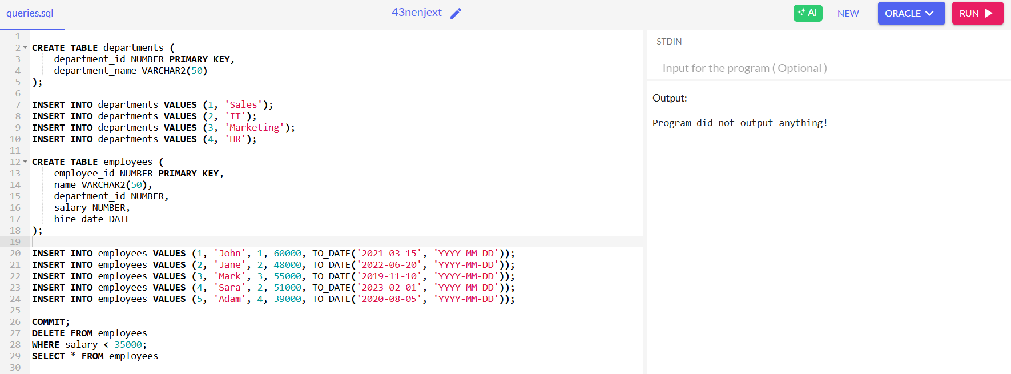

### 18. **Creating a Table**

- Write an SQL query to create a table called `customers` with columns `customer_id`, `first_name`, `last_name`, `email`, and `phone_number`.

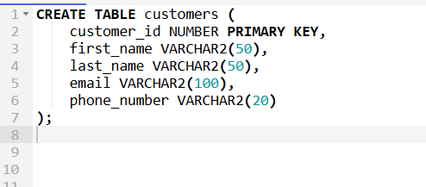

### 19. **Modifying a Table (ALTER)**

- Write an SQL query to add a new column `hire_date` to the `employees` table.

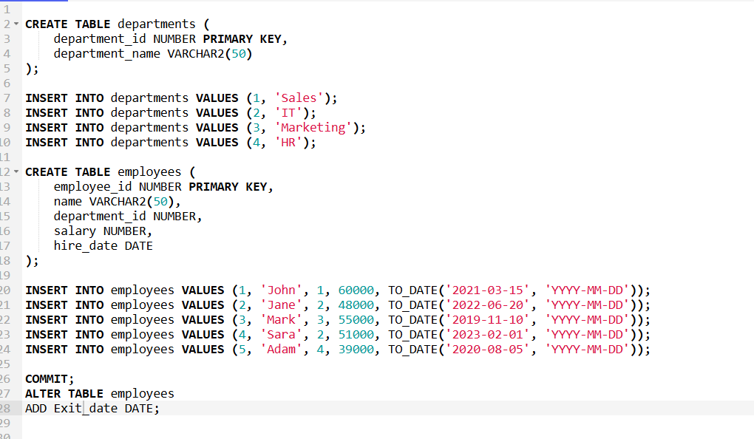

### 20. **Dropping a Table**

- Write an SQL query to drop the `temporary_employees` table if it exists.

